|  |  |
| --- | --- |
| **Cairo University**  **Faculty of Engineering**  **Computer Engineering Department**  **CMP2020** | **SEM -team 5** |
| Introduction to Database Systems      Schema Diagram Report  Bank Management System  Team Number: 5  **Team Members:**  Rawaa Ahmed Said Hanafy 1 33  Esraa Amr Mohammed Amr 1 17  Bishoy Atef Tadros 1 23  Robert Mounir isaac 1 32  **Contact info:**  Rawaa Ahmed : [rawaa.hanafy00@ eng-st.cu.edu.eg](mailto:rawaa.hanafy00@%20eng-st.cu.edu.eg)  Esraa Amr : [esraa.amr26@eng-st.cu.edu.eg](mailto:esraa.amr26@eng-st.cu.edu.eg)  Bishoy Atef Tadros : [Bishoy.tadros99@eng-st.cu.edu.eg](mailto:Bishoy.tadros99@eng-st.cu.edu.eg) | |

Robert Mounir isaac : [robert.boules01@eng-st.cu.edu.eg](mailto:robert.boules01@eng-st.cu.edu.eg)

Contents

* ER Diagram.
* Schema Diagram.
* Database Constraints.

**ER Diagram:**

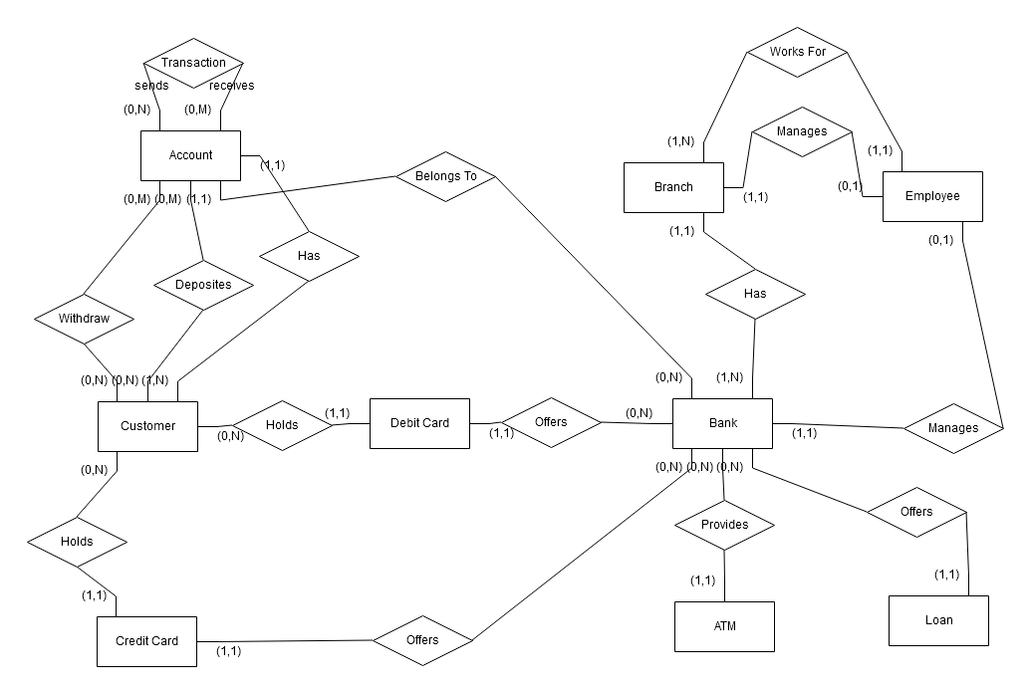

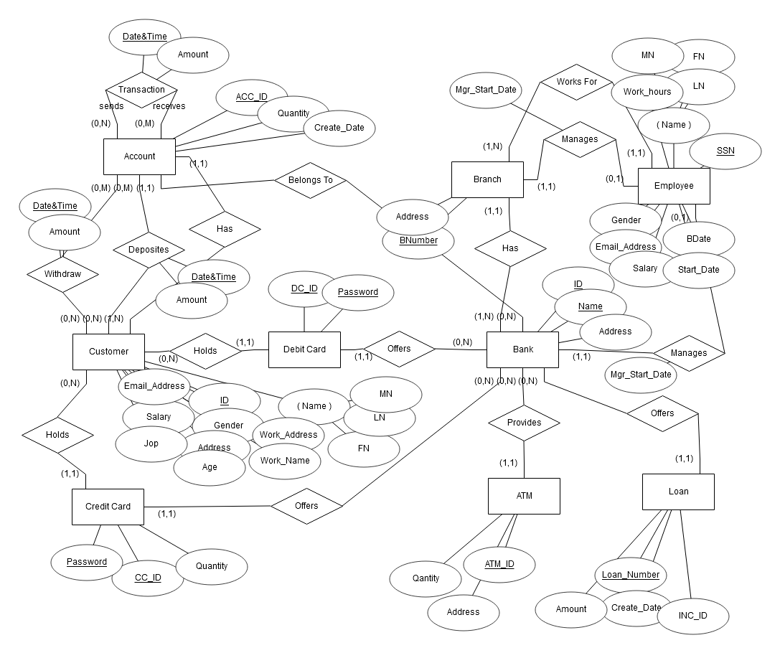

**Schema Diagram:**

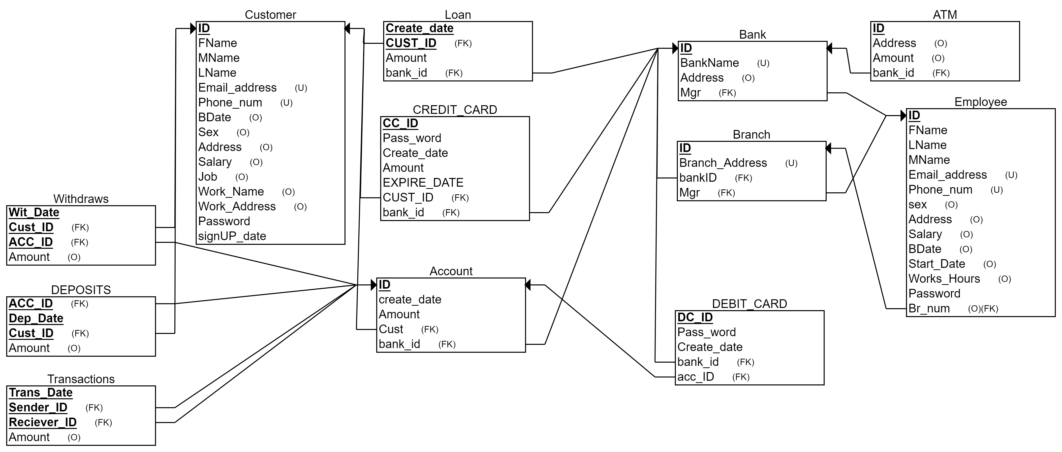

**Database Constraints:**

* It is not allowed to delete a customer from the database if he has unpaid loans.
* If we deleted a bank, all of its branches are also deleted.
* If we deleted a branch that doesn’t necessarily mean that the employees in it are deleted.
* If we deleted the manager, we don’t delete the branch or bank that they manage.
* When we delete the bank, we delete all the accounts it has.
* When we delete the customer, we delete his account.
* When a bank is deleted, its debit cards and credit cards are deleted too.
* If an account is deleted, its debit cards are deleted.
* The credit card is also deleted when its customer is deleted.
* When the bank is deleted the ATMs are deleted.
* When the account is deleted, we delete all the deposits he made.
* When the account is deleted, we delete all the withdrawals he made.
* When an account is deleted, all the transactions between it and any other account are deleted.